Resumo de instruções uteis

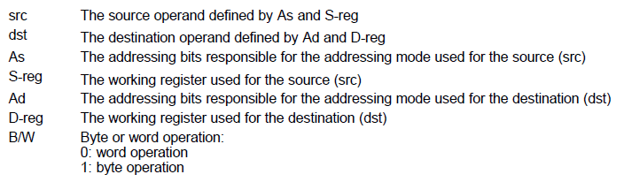

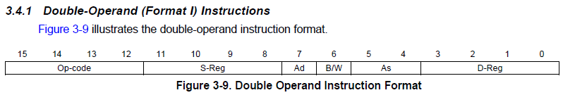

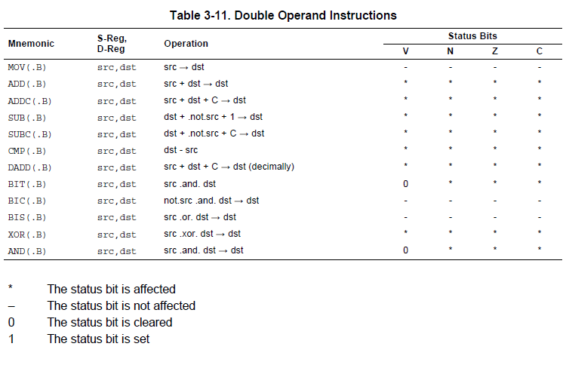

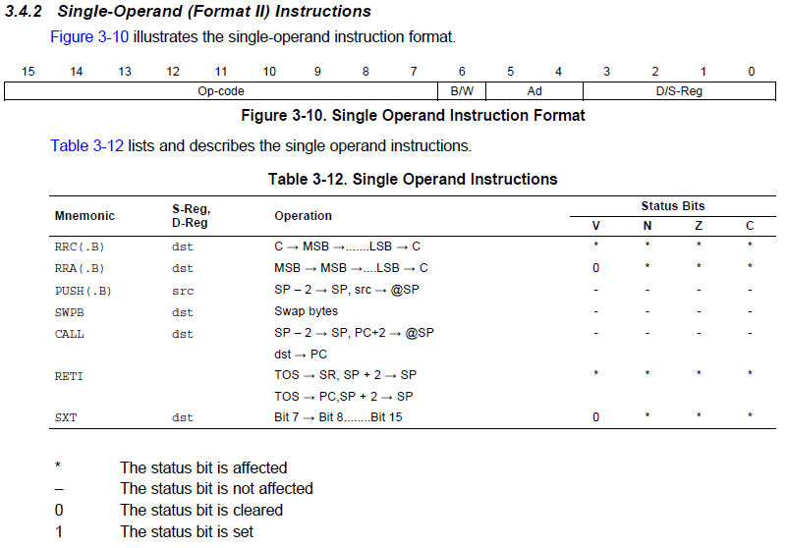

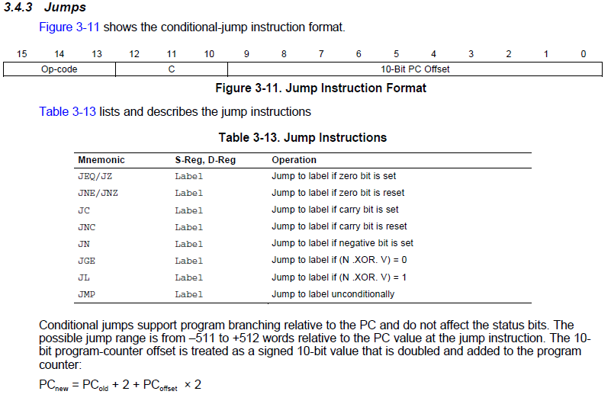

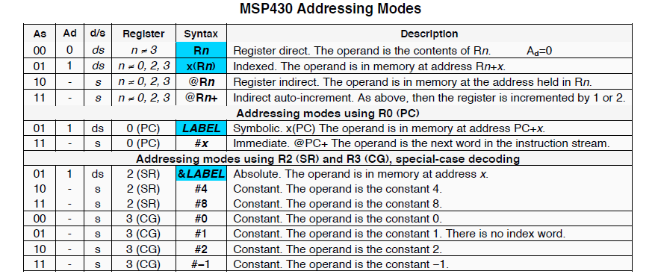

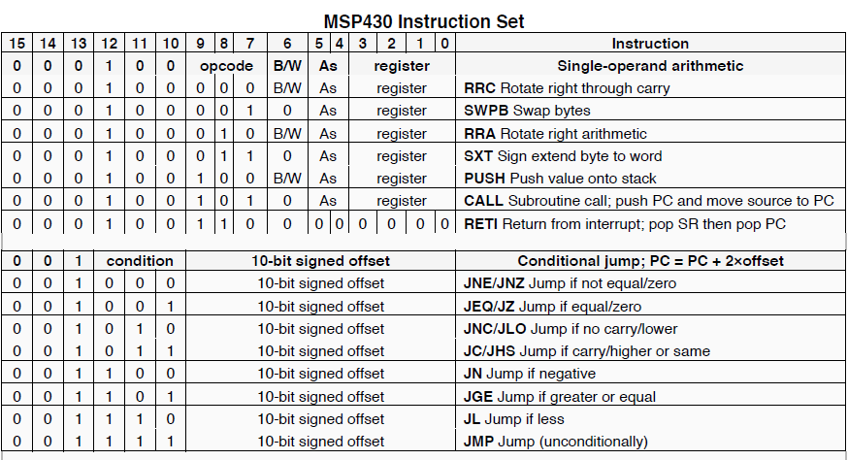

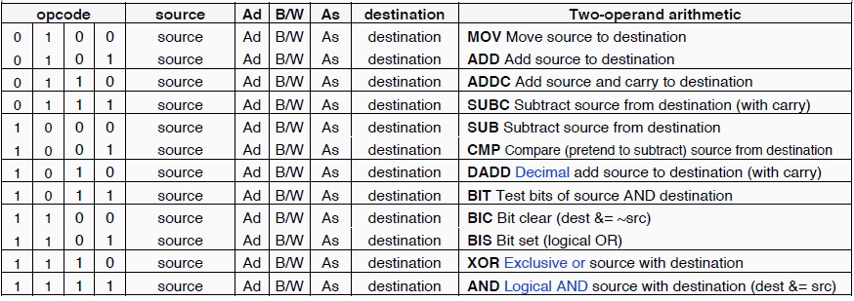

--OPCOPE TIPO R:

MOV const, Rd -> 0100 CCCCCCCC 1 RRRd

MOV Rs, Rd -> 0100 RRRs 000000 RRRd

ADD const, Rd -> 0101 CCCCCCCC 1 RRRd

ADD Rs, Rd -> 0101 RRRs 000000 RRRd

SUB const, Rd -> 1000 CCCCCCCC 1 RRRd

SUB Rs, Rd -> 1000 RRRs 000000 RRRd

C – valor referente a constante

Rs – registrador fonte

Rd – registrador destino

E - endereço

--OPCODE TIPO J:

JMP endereco -> 001111 EEEEEEEEEE

NOP -> 0000000000000000